CONSERVATION COMMISSION  Telephone (203) 563-0180  Fax (203) 563-0284 | 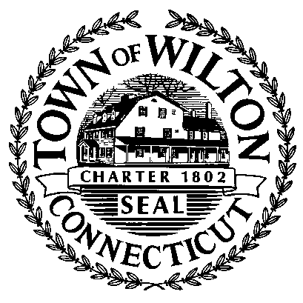 | TOWN HALL  238 Danbury Road  Wilton, Connecticut 06897
WILTON CONSERVATION COMMISSION

WEDNESDAY February 1, 2012 – 7:30 P.M.

TOWN HALL ANNEX - MEETING ROOM “A”

AGENDA

- CALL TO ORDER

- INLAND WETLAND REFERRALS

a. WET#2081(S) – HALAN – 295 Newtown Turnpike – construction of a 3-car detached garage 36 ft. from the East Branch Saugatuck River

b. WET#2082(S) – FOSTERHOUSE – 122 Olmstead Hill Road – restore pond and expand existing wetlands, including B100a

- PLANNING AND ZONING REFERRALS

a. REG#12337, Kevin O’Brien – amend regulations for revised area and bulk requirements in Wilton Center District

b. REG#12338, Kevin O’Brien – amend regulations pertaining to Special Permit uses in the Wilton Center District

c. CHZ#12339, Kevin O’Brien – 291 & 300 Danbury Road and 7 Station Road – zone change from General Business (GB) and Residential (R-1A) to Wilton Center District (WC)

- ONGOING BUSINESS
      - Parks - All
      - Recycling – Begor
      - Work with other Commissions/Committees
          - Tree Committee
          - Energy Committee
          - Go Green
      - Regional Projects
          - FFD Co. Deer Management Alliance
          - Norwalk River Valley Trail

- NEW BUSINESS

      - Community Garden at Sackett Preserve
      - Newsletter

VI. LIAISON REPORT

a. January Liaison Report – Begor and Merrill
b. February Liaison = Gillespie

VI. DIRECTORS REPORT

VIII. APPROVAL OF MINUTES – 1/4/12

IX. ADJOURN

