238 Danbury Road  Wilton, CT 06897  www.wiltonct.org | 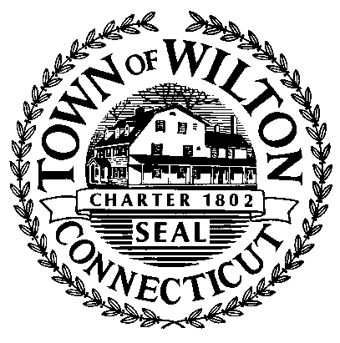  Wilton Security Task Force | Harold E. Clark  Chairman  Police Chief Michael Lombardo  Vice Chairman  John Suchy  Terrie Schwartz  John Logan  Ken Post  John Murphy  Jory Higgins  Roseann DeSimone  Dr. Kevin Smith

WILTON SECURITY TASK FORCE MEETING

Wednesday, October 22, 2014
7:30 PM
Middlebrook School Library
131 School Road
Wilton

1. Call to Order

2. Chairman welcomes Dr. Kevin Smith to the Task Force

3. Approval of the September 24, 2014 Meeting Minutes

4. Old Business

- Progress on installation of additional security items:
stumbling blocks, opportunities, etc.

5. New Business

- Tour Middlebrook School

- Consideration of overall needs for mass communication and integrated alarm system
- Discussion on tailoring the above to other Wilton schools and public buildings
- Consideration of any critical safety improvement must haves at Miller Driscoll before and after renovation

6. Next Meeting Date

7. Adjournment

